



Index

1. Software description **2**

2. Software installation **2**

2.1. Windows 10 2

2.1.1. Octave installation 2

2.1.2. Python installation 6

2.1.3. Set environment variables 8

2.1.4. SonoUno installation 15

2.1.4.1. Installation with pip 15

2.1.4.2. Installation from source 15

2.1.5. Run the software 17

2.1.6. Possible problems 18

3. Import a file to the software **19**

# 1. Software description

SonoUno is a sonification software for two column tables of astronomical data. The software is being developed based on the study of other software (Sonification Sandbox, MathTrax and xSonify) and standards of accessibility like the ISO 9241-171:2008 (Guidance on software accessibility). In order to develop the first approach of graphical user interface, we perform a theoretical framework based on bibliography of user cases, focused on blind and visual impairment people.

The develop language is Python and we use modular design, in order to do collaborative work. The sonoUno now is multiplatform, tested on windows 10, Ubuntu 16.04 and Mac High Sierra; the development team work continuously to maintain this benefit. The principal goal of the SonoUno is to allow the user to open data files (txt or csv extension), reproduce the plot and sonification of the data. At the moment, the sonification is perform by variation of pitch in different instruments.

Additionally, SonoUno allow to select a specific range of data on the ‘x’ axis, mark and save point of interest in the data, apply predefined mathematical functions (for example, logarithm and square) and manipulate the data arrays with an Octave interface. In the section settings, the user can configure the plot and change between several predefined instruments (acoustic piano, clavinet, celesta and tubular bells, between others). We expect to include more sound configurations shortly.

Finally, the software allows the user to save the sound, the plot, a text file with the points marked on the data and a csv file with the plotted data.

# 2. Software installation

## 2.1. Windows 10

### 2.1.1. Octave installation

The octave installer can be downloaded from the official website, here we paste the links to octave v5.2 for windows 64 bits and 32 bits.

Octave v5.2 - 64 bits:

<https://ftpmirror.gnu.org/octave/windows/octave-5.2.0_1-w64-installer.exe>

Octave v5.2 - 32 bits:

<https://ftpmirror.gnu.org/octave/windows/octave-5.2.0_1-w32-installer.exe>

Octave official websites, downloads section:

<https://www.gnu.org/software/octave/#install>

Once you have the installer, double click on it and start the installation of octave. The process is explained with the next pictures. First, if you don’t have java JRE installed on your system, a message appears and inform you that you can install it later if you want (Image 1). Unless you want to use java libraries, for this software purpose is not needed the JRE installation.

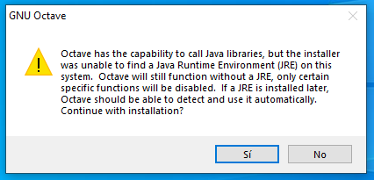

*Image 1 - Message from octave that advise that you can install JRE later and use the java libraries from octave if you want.*

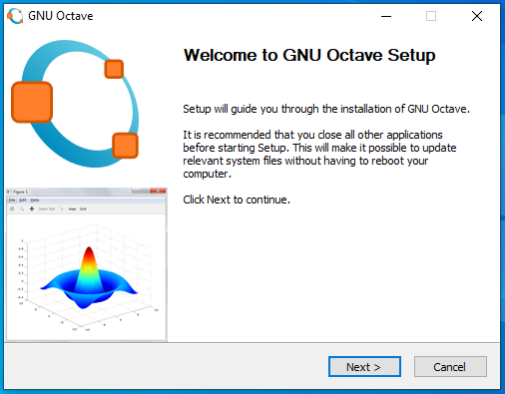

*Image 2 - Initial framework of octave installation program. This frame contain a welcome message.*

The first framework of the installation program contain a welcome message (Image 2), once you read it, you can press ‘Next’ and continue with the installation. The next window contain the license agreement, to accept it and continue you have to press ‘Next’ (Image 3).

The next frame present some checkboxes, which ones ask if the installation is for all users, if you want to create a desktop shortcut and if you want to register m file type with octave; all the checkboxes are selected by default (Image 4). In addition, it ask for the BLAS library implementation, which is OpenBLAS by default. In this window, you can leave all the default values if you want.

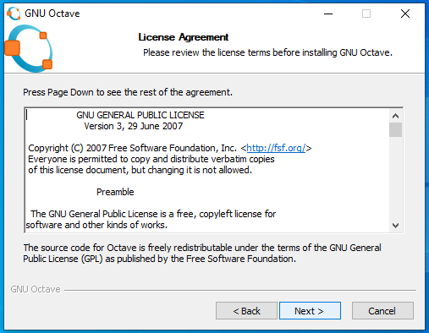

*Image 3 - This framework of the octave installation contain the license agreement.*

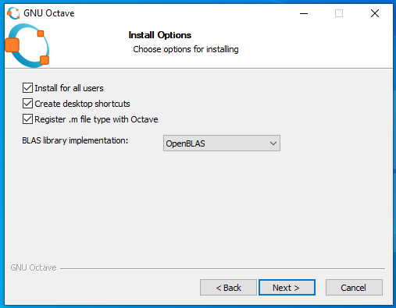

*Image 4 - This framework of the octave installation ask if the installation is for all users, if you want to create a desktop shortcut and if you want to register m file type with octave; all the checkboxes are selected by default. In addition, it ask for the BLAS library implementation, which is OpenBLAS by default. In this window, you can leave all the default values if you want.*

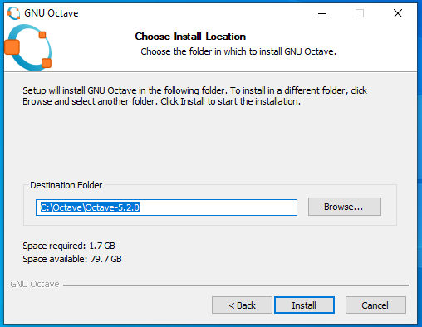

*Image 5 - This framework show the default destination folder (C:\Octave\Octave-5.2.0) and the space required (1.7 GB). The destination folder can be changed by the user.*

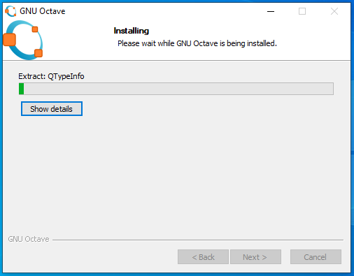

*Image 6 - This framework shows a progress bar that indicate the installation progress.*

Next window allow to choose install location (Image 5), by default is ‘C:\Octave\Octave-version’. You have to remember or take note of the install location to set the environment variables later.

Next, a progress bar is shown indicating the installation progress (Image 6). Finally, the installer show a message that inform that the software has been installed and contain two checkboxes: ‘Run GNU Octave’ and ‘Show Readme’, the two of them are selected by default.

After this installation you can proceed with the python and libraries installation.

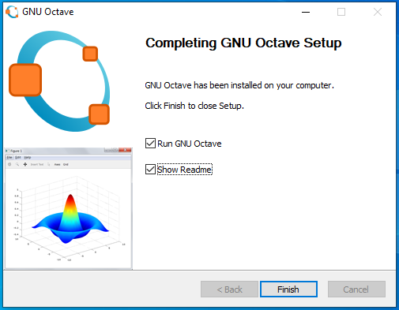

*Image 7 - This framework is the last one, inform that the installation is completed and show two checkboxes with: Run GNU Octave and Show Readme, the two of them are selected.*

### 2.1.2. Python installation

If you have python 3 installed on the computer you can skip this section, if not you can download an installer from the official website <https://www.python.org/downloads/windows/>. Additionally, we paste the link of the exe installer for windows 10: <https://www.python.org/ftp/python/3.8.3/python-3.8.3-amd64.exe>

Once you have the executable file, the first framework after you open it show two installation options (Image 8):

1. Install Now: indicate the path where the software is going to be installed and other default configurations.
2. Customize installation: this option show other windows and allow to set the installation folder and some other options.

In addition, at window bottom there are two checkboxes: the first is selected and install launcher for all user; the second is unselected and add python to PATH, you have to select this one (Image 9). If you don’t select this checkbox you have to set the python’s PATH after the installation.

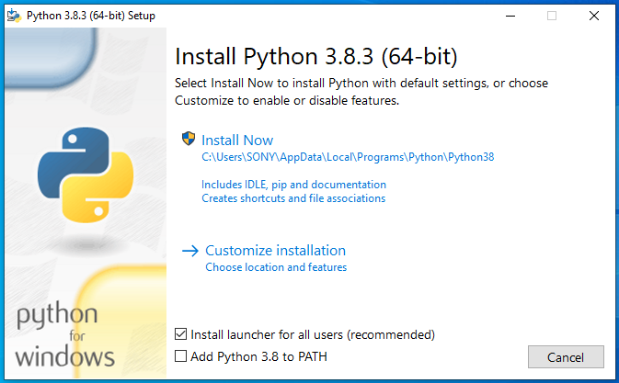

*Image 8 - This is the first frame of python installer. Shown two installation options (default and customize installation) and two checkboxes (install launcher for all users and add python to PATH).*

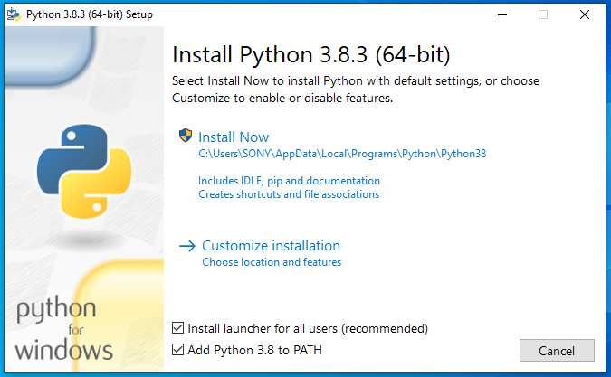

*Image 9 - This is the first framework again but with the checkbox ‘Add python to PATH’ checked.*

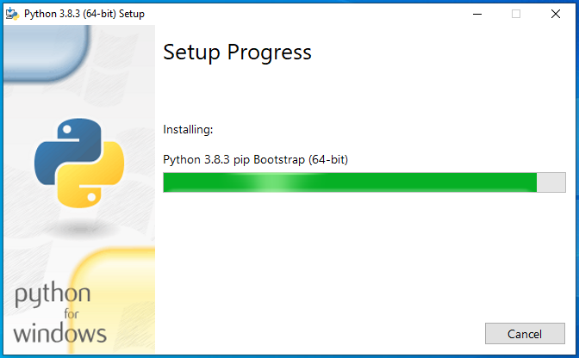

*Image 10 - When you select ‘Install now’ the next frame contain a progress bar indicating the installation progress.*

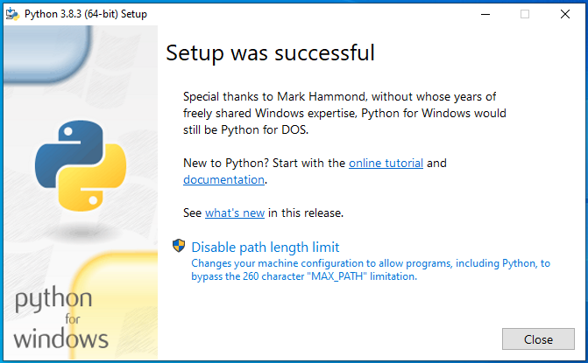

*Image 11 - This is the last frame, shown acknowledgment and some other messages.*

After set the checkbox on the first framework, if you select ‘Install now’ the next window shows a progress bar indicating the installation progress (Image 10). After the installation is finished the last framework shows the acknowledgment, the link to documentation and an option to disable path length limit (Image 11).

### 2.1.3. Set environment variables

The next important step is to set the environment variables, the only part that differs between Windows 7 and 10 is the location of control panel button on the start menu. On Windows 7, click the start menu and the control panel button is on the right (Image 12), but on Windows 10, the user have to open “All apps” and search for “Window system” folder, the control panel button is inside this folder (Image 13).

In the control panel window, select “System and security” (Image 14), then “System” (Image 15) and finally, “Advance system settings” (Image 16). In the new window bottom the user can find the “Environment variables” button (Image 17), witch one open the environment variables window (Image 18), where the user can set the PATH variable.

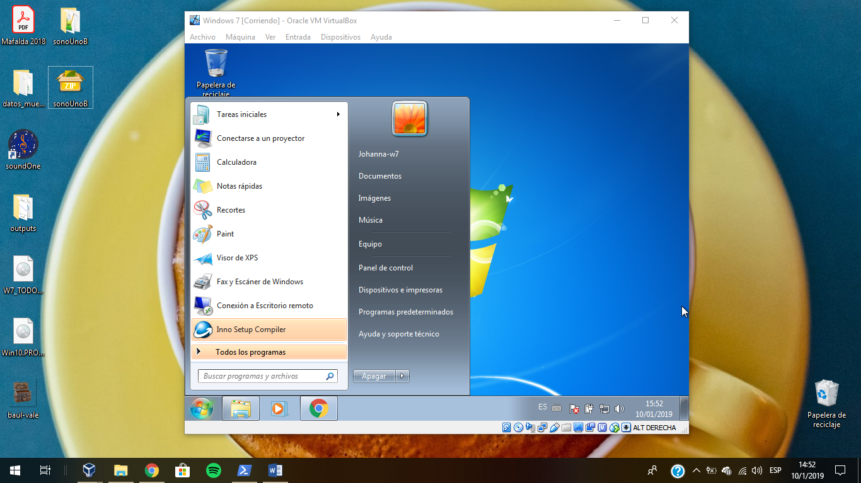 

*Image 12 - Selection of control panel on the start menu of Windows 7 system.*

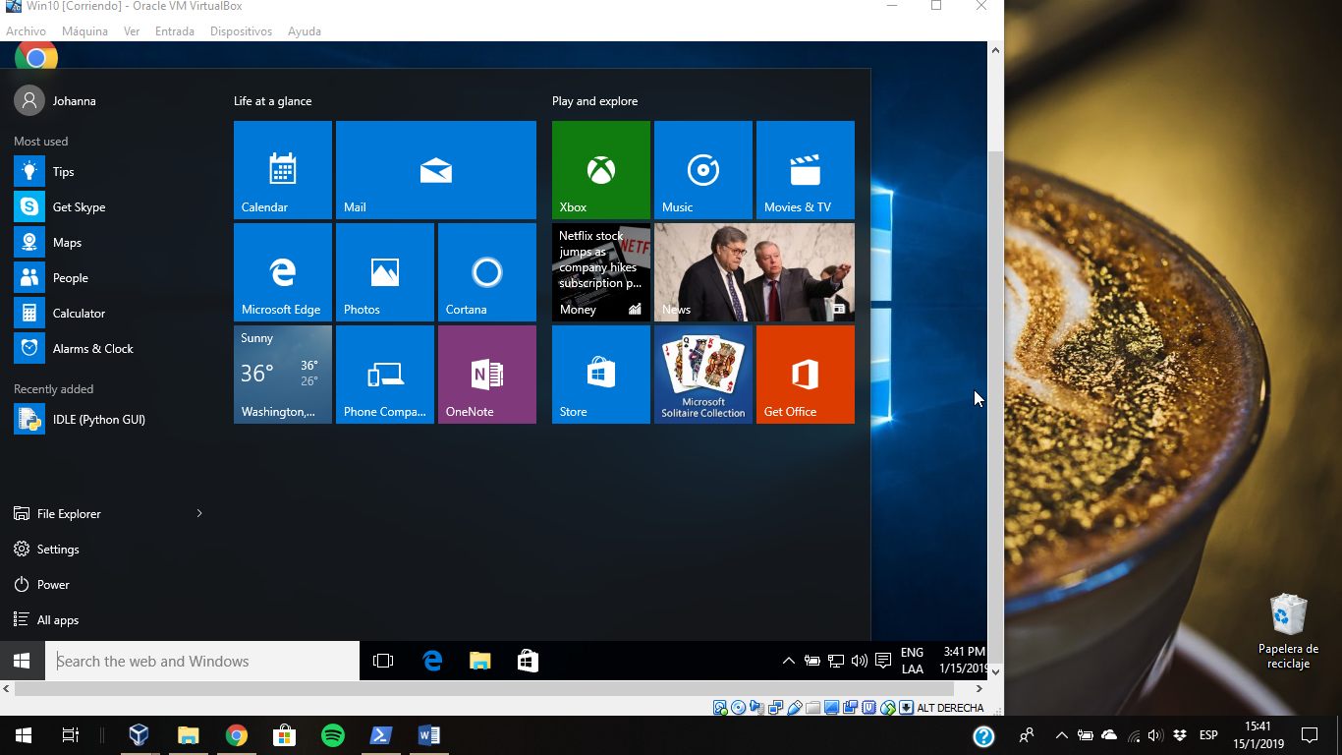 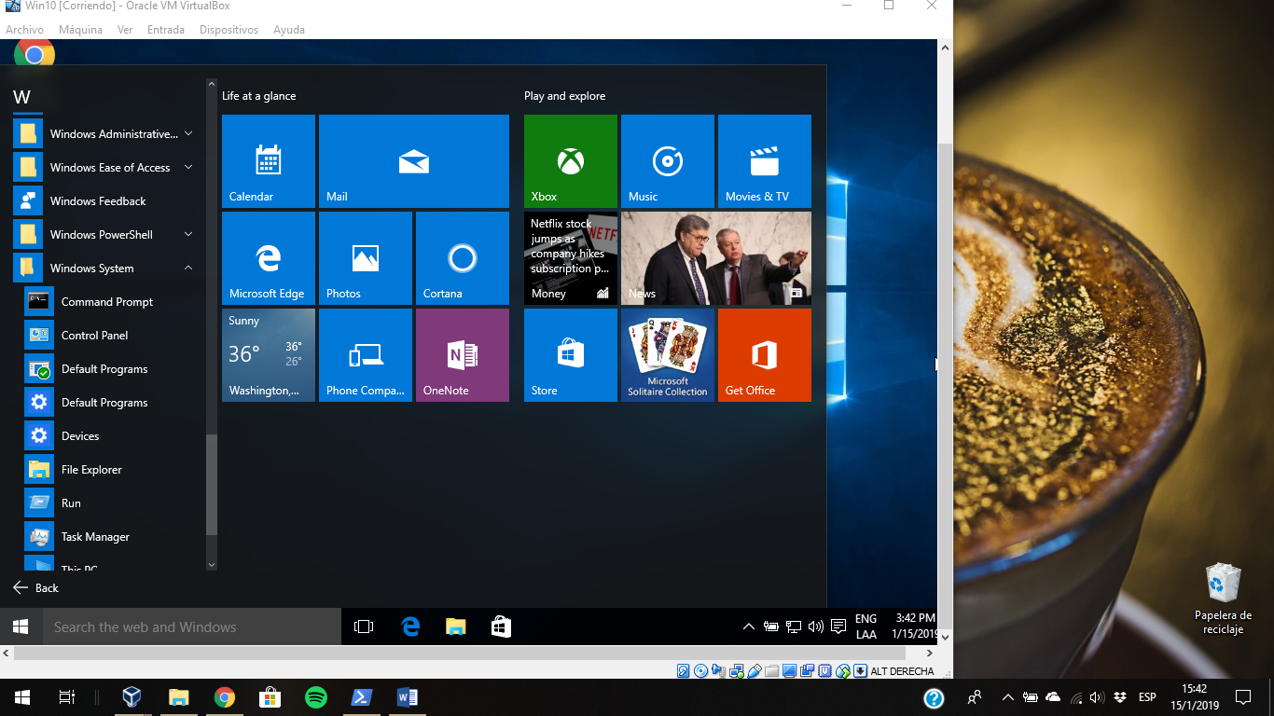

*Image 13 - Selection of control panel on the start menu of Windows 10 system.*

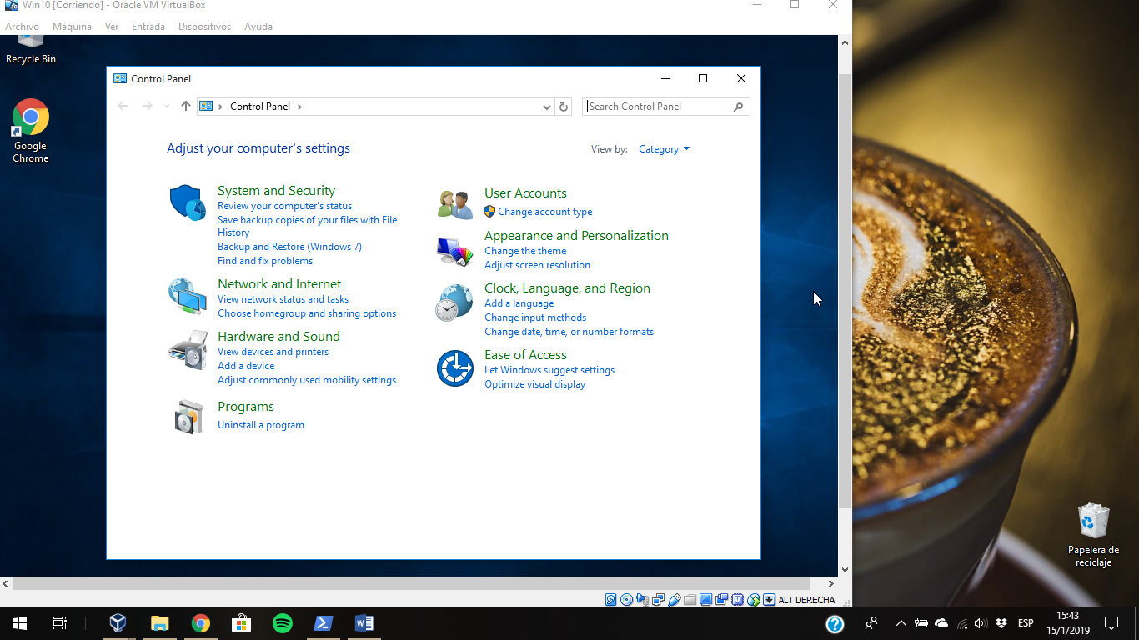

*Image 14 – “System and security” section marked with a rectangle on the control panel.*

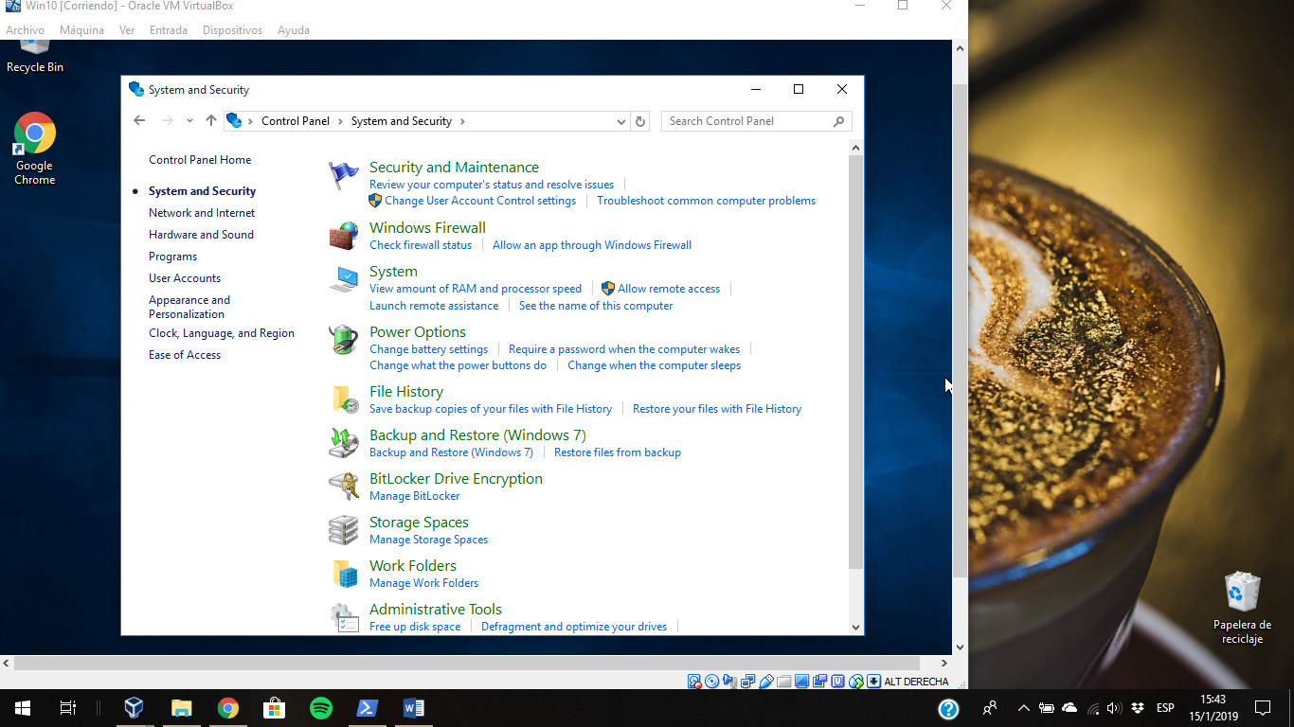

*Image 15 - System section marked with a rectangle on “System and security”.*

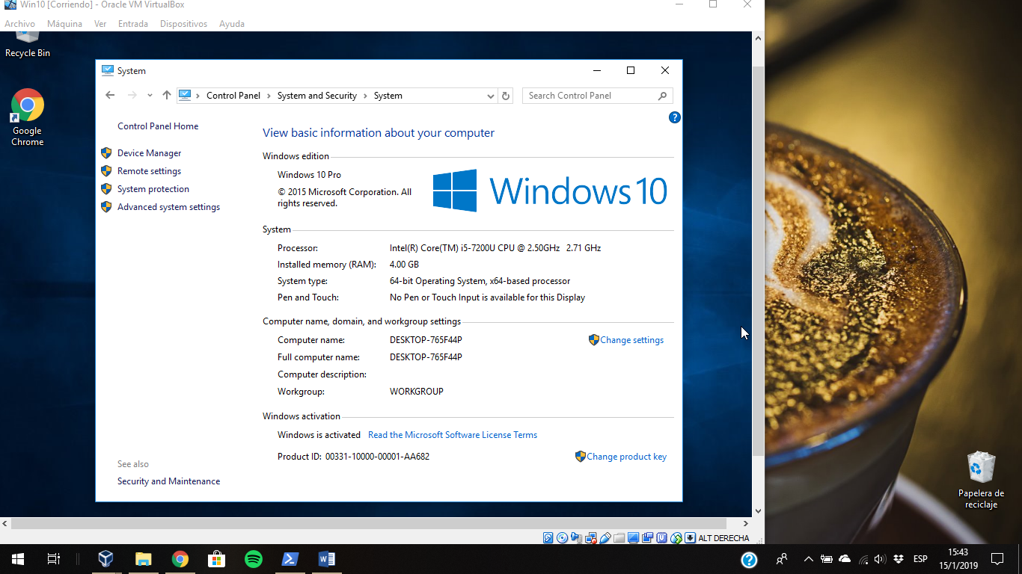

*Image 16 - "Advanced system settings" section marked with a rectangle on "System".*

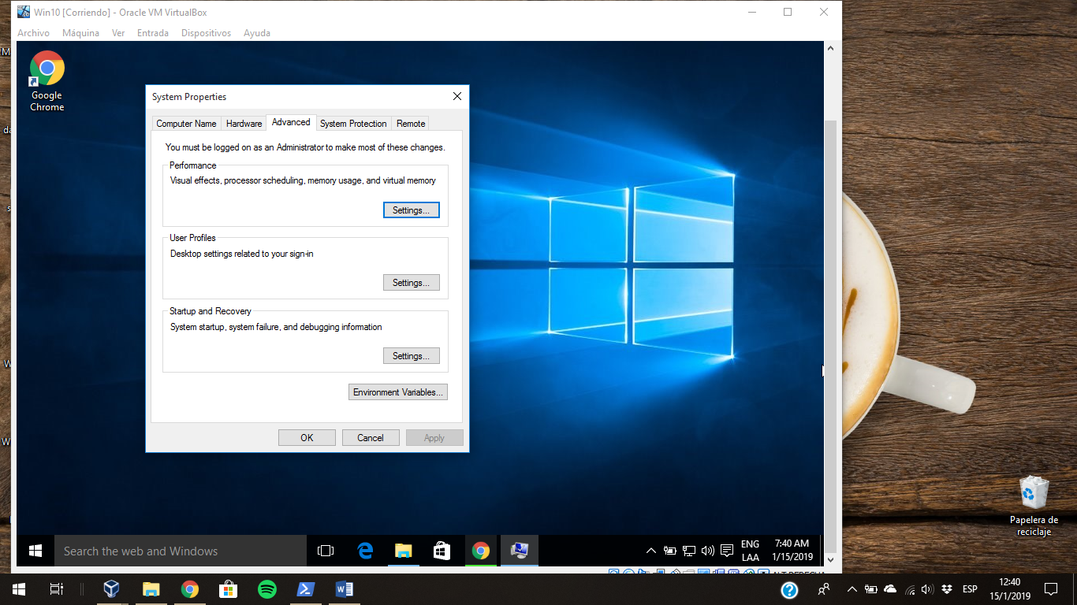

*Image 17 - "Environment Variables" button marked with a rectangle on "System properties".*

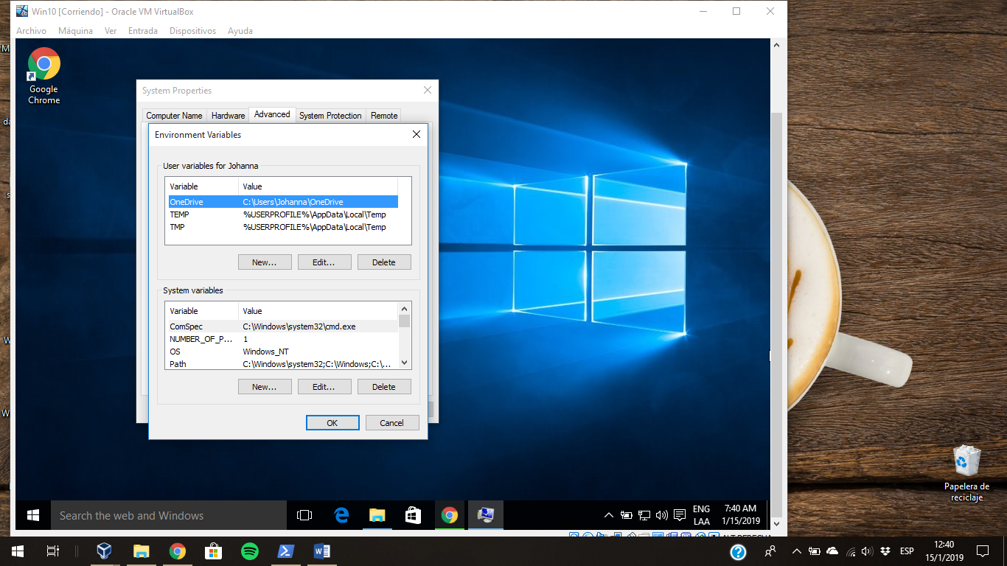

*Image 18 - Environment variables window.*

Another way to access to the environment variables windows is typing “environment variable” on the start menu (Image 19), the button “Edit the system environment variables” open the same window that the first way (Image 18).

Once the user is in the environment variables window, if the user variable PATH exist, the user has to click on “Edit” and add the new path to the variable. On the other hand, if the PATH user variable does not exist, the user must click on the “New” button, that action open a pop-up window where the user can set the variable name and value (Image 20). The name of the variable is “PATH” and the value is the new path (Image 21), in this case the directory of the Octave folder and the mingw64/bin folder inside it (by default: ‘C:\Octave\Octave-5.1.0.0’ and ‘C:\Octave\Octave-5.1.0.0\mingw64\bin’). If you need to add python too, it directory depends on the installation, check on your system where is it, there are two possible places:

* C:\Users\user_name\AppData\Local\Programs\Python\Python38\
* C:\Python38\

one you find python path, you have to add ‘python_path\Scripts’. Finally, click Ok and Ok.

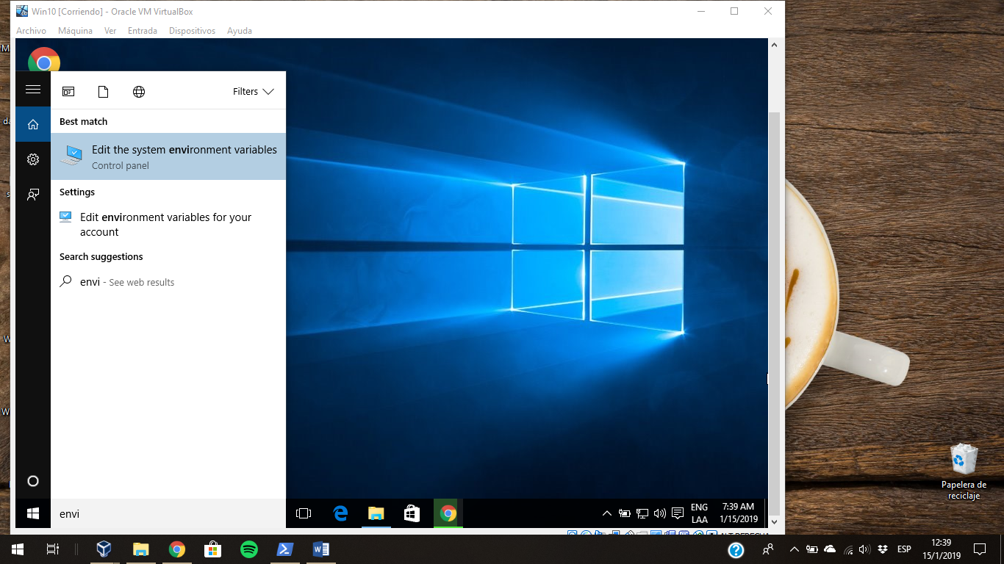

*Image 19 - Search on start menu typing "Environment variable".*

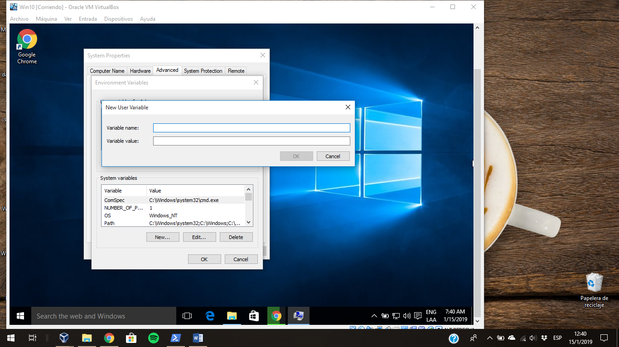

*Image 20 - Press the new button on the user variables section of the environment variable window.*

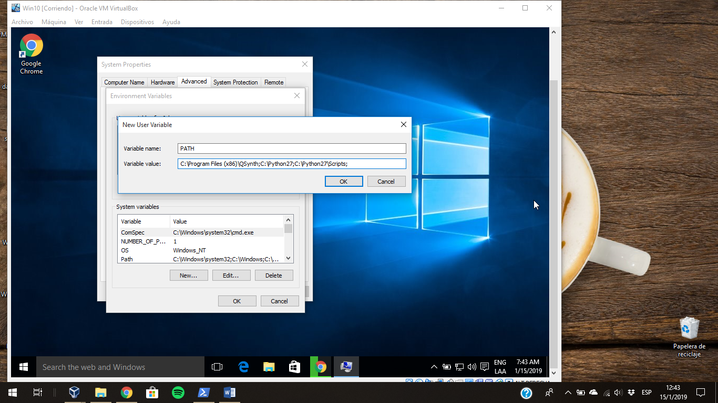

*Image 21 - Select the name PATH and paste the directories on the value box, this image is illustrative and don’t contain the correct path for you.*

### 2.1.4. SonoUno installation

#### 2.1.4.1. Installation with pip

After you install python3 and verify that pip is installed, you can write the next commands on cmd or Windows powershell to install sonoUno:

* python3 -m pip install sonoUno

To open the sonoUno software:

* sonoUno

#### 2.1.4.2. Installation from source

To install the libraries the user have to open the command window (Image 22), typing “cmd” on the start menu. Other option is to use the PowerShell of Windows (Image 23).

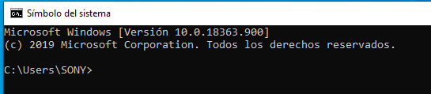

*Image 22 - Command window on Windows operative system.*

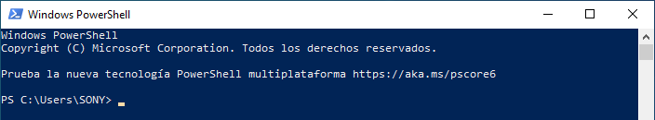

*Image 23 - Windows PowerShell on Windows operative system.*

Once in the window, follow the nexts steps:

1. Install wxPython with the next command (Image 24):
   1. python -m pip install -U wxPython

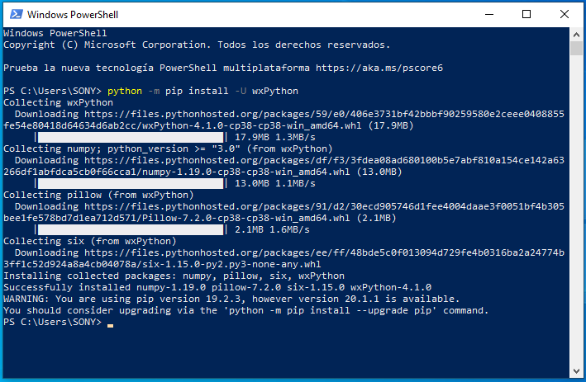

*Image 24 - Installation of wxPython with the previous command.*

**NOTE**: The installation can take several minutes, be patient. If the installation takes more than 30 minutes cancel the process (Ctrl+C) and execute the command once again. The aspect of the installation, can be seeing in Image 24.

1. Install matplotlib (Image 25):
   1. python -m pip install -U matplotlib

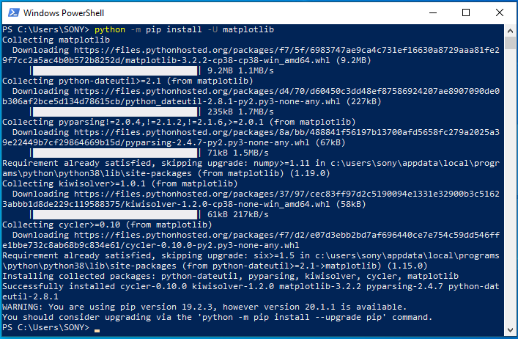

*Image 25 – Part of the installation of matplotlib with the previous command.*

1. Install pandas (Image 26):
   1. python -m pip install -U pandas

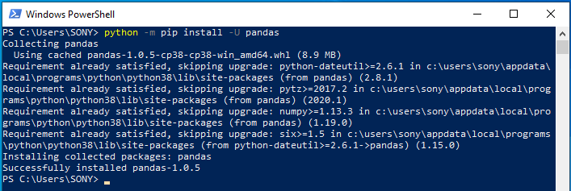

*Image 26 - Installation of pandas with the previous command.*

1. Install numpy (Image 27):
   1. python -m pip install -U numpy

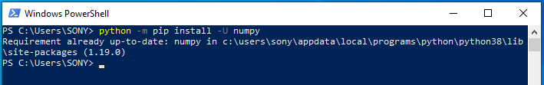

*Image 27 - Installation of numpy with the previous command.*

1. Install pygame (Image 28):
   1. python -m pip install -U pygame

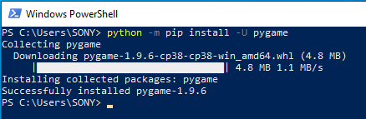

*Image 28 - Installation of pygame with the previous command.*

1. Install oct2py (Image 29):
   1. python -m pip install -U oct2py

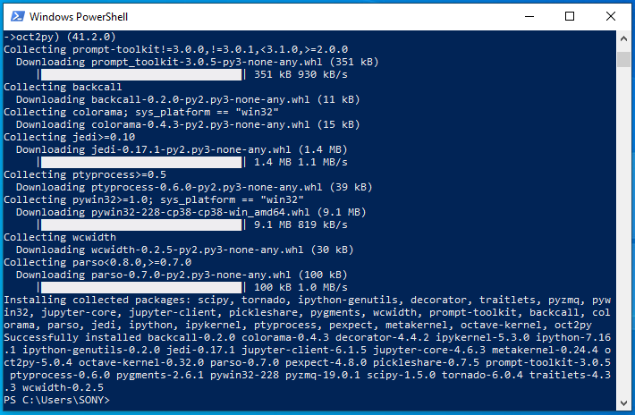

*Image 29 - Installation of oct2py with the previous command.*

**NOTE: if any of the last libraries (from 1 to 6) is missing, the soft does not run. The installation can take several minutes.**

### 2.1.5. Run the software

To open the software, follow the next steps:

1. Unzip the file, if it is compressed. If you want to clone from github use the next line:
   1. git clone https://github.com/sonoUnoTeam/sonoUno.git
2. Open a terminal and go to the software folder. Probably you have more than one folder before you can run SonoUno. To check in which folder is sonoUno, use the command “dir” (Image 30). The sonoUno must be among the files and the manual in the folder.

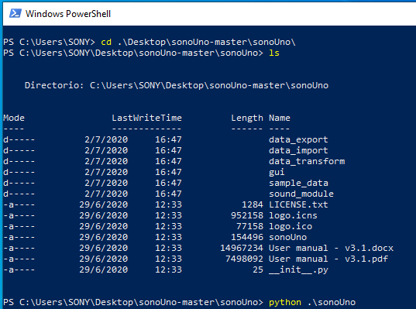

*Image 30 - Location of the sonoUno on the command line.*

1. Once you are sure that you are at the right folder, make:
   1. python sonoUno

A window must be open (Image 31), if that is the case, the soft is ready to be used.

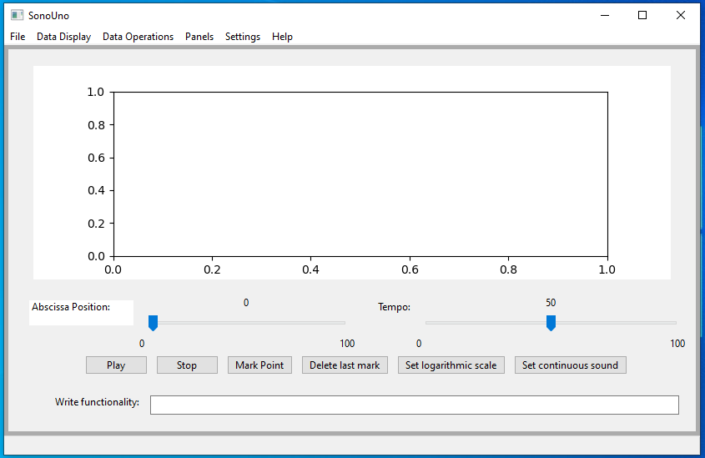

*Image 31 - SonoUno main window on Windows.*

### 2.1.6. Possible problems

Some users report that sometimes python 3.8 can’t be open from Windows PowerShell. If you are sure that the environment variables are correct and you can’t open python from Windows PowerShell, try to open it with ‘cmd’. If the problem persist or you have another problem, contact the development team or open an issue on GitHub.

# 3. Import a file to the software

Once the software is installed, and you can open it, you are ready to try your first dataset. The initial window of the software only shows the plot and the reproduction options of the data (Image 31), the other functionalities are hide and were shown in the user manual. This design was based on a user cases study and ISO standards.

In order to probe the SonoUno, you have to import a data file. If you don’t have a data file, the installer provides a folder named “data” with simple functions on the installation directory or you can download this folder from github.

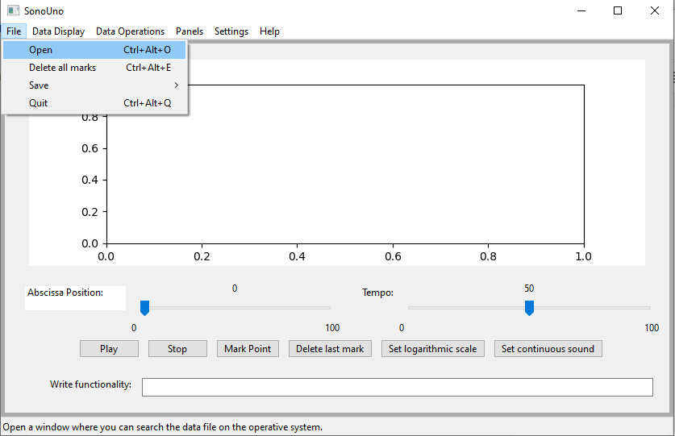

*Image 32 - Open a file: choose the item Open on the menu File.*

The first step to open a data file, is to select the item Open on the menu File (Image 32). This action shows a new window of the file system of the computer, where you can choose the data file. Once you have the data file selected, press the button “Open” (Image 33).

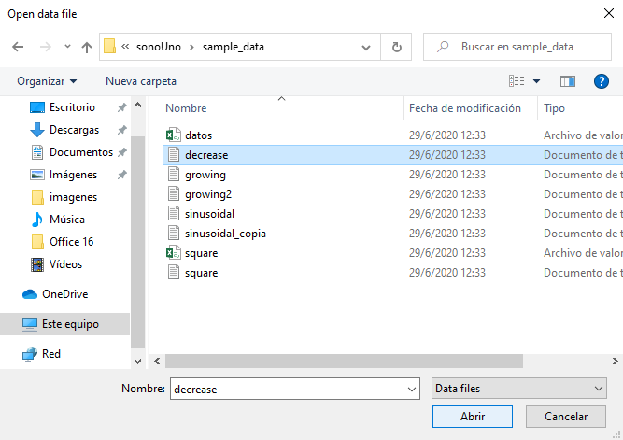

*Image 33 - New window of the file system of the computer.*

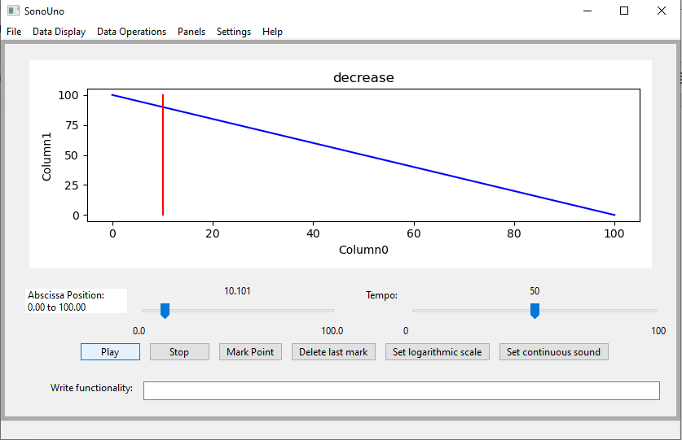

*Image 34 - Reproduction of the data file after press the button Play.*

After open the data file, the SonoUno show the plot and is ready to reproduce the sound. In order to reproduce it, you have to press the button Play (Image 34). If the software installation is correct, you must listen a pitch variation and see a red vertical bar moving through the data, this bar indicate the position of the data that is been sonificated.

If the software doesn’t produce sound, check the speakers or headphones on your computer. If the problems continue or you have another problem, inform this to the developer team.